Creating Your Own Actors

Introduction
This guide is designed to show how to add your own actors to the workflow. These can be declared and used outside the core distribution. It is possible to obfuscate source code to avoid it from being usable if it is desirable to protect your intellectual property. A small amount experience of creating an eclipse plugins is assumed for this guide but any competent programmer may follow it. Much of the complexity of this explanation is concerned with explaining how to use eclipse rather than how to create a workflow actor, which should be easy we hope!

Create Your First Actor

Introduction and short cut
You can download the example in this guide at: https://github.com/DawnScience/dawn-examples.git
Rather than read this guide, if you know eclipse it is possible to checkout this plugin and modify it for your needs.

Developing DAWB
It is best to check out DAWB to create actors. (You could instead have the compiled versions of the dawb plugins in your target or classpath.) Assuming you are checking out DAWB, using eclipse helios with subversive, there are instructions here:
http://code.google.com/a/eclipselabs.org/p/dawb/wiki/DevelDAWB
At the end of this process you will be able to use the DAWB debug session and run the product in debug mode which makes it easy to develop actors. (If the debug does not start on your platform, try opening the debug session 'DAWB' and go to the plug-ins tab. Use 'Add Required Plugins' and 'Validate Plugins' buttons to get the plugin configuration correct.)
This step is by far the hardest if you are new to eclipse. Please contact support@dawb.org if you get stuck.

New Plugin
Using the PDE version of eclipse, create a new plugin for your actors. You should name the plugin something like <domain name>.<project>.<sub-project> for instance “org.dawb.passerelle.actors.io”.
On the 'Dependencies' tab be sure to declare 'org.dawb.passerelle.common' , 'com.isencia.passerelle.actor', 'com.isencia.passerelle.workbench.model' and 'ptolemy.core' to the dependencies so you have something like:
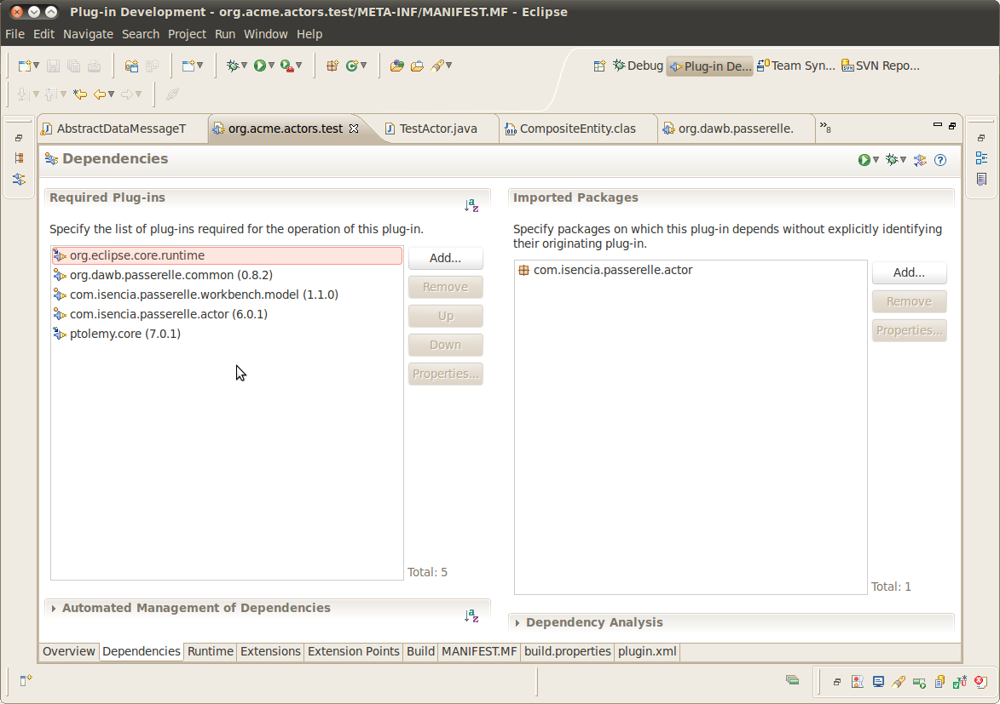
In order for the workflow to run in an eclipse application outside the application, eclipse buddy is used. To do this, add the line:
Eclipse-RegisterBuddy: com.isencia.passerelle.engine, ptolemy.core, com.isencia.passerelle.actor
in the MANIFEST.MF, just go to the MANIFEST.MF tab to do this. It will look like this:
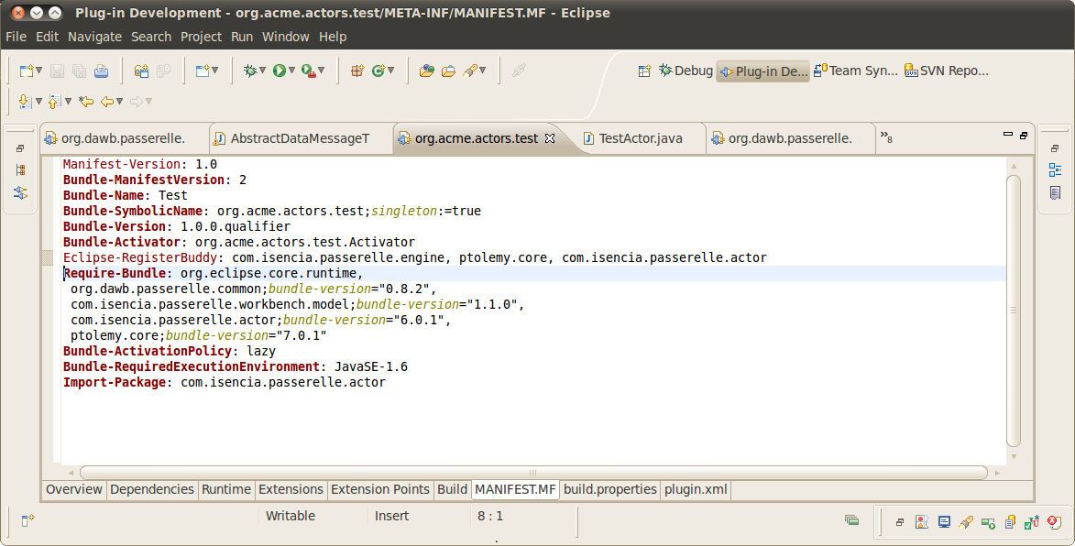

New Actor Class
Your actor class should extend a specific type of class, one of the actors in org.dawb.passerelle.common, for instance AbstractDataMessageTransformer is most commonly used. There are also actors which are Sinks and Sources (you may need to read Ptolemy documentation to understand more about these concepts).
Create a class extending AbstractDataMessageTransformer and add the default constructor and methods (automatic links appear in eclipse to do this) so that your actor looks something like this:
package org.acme.actors.test;

import java.util.List;

import org.dawb.passerelle.common.actors.AbstractDataMessageTransformer;
import org.dawb.passerelle.common.message.DataMessageComponent;
import org.dawb.passerelle.common.message.MessageUtils;

import ptolemy.kernel.CompositeEntity;
import ptolemy.kernel.util.IllegalActionException;
import ptolemy.kernel.util.NameDuplicationException;

import com.isencia.passerelle.actor.ProcessingException;

public class TestActor extends AbstractDataMessageTransformer {

/**
*
*/
private static final long serialVersionUID = -8808664164352113469L;

public TestActor(CompositeEntity container, String name) throws NameDuplicationException, IllegalActionException {
super(container, name);
}

@Override
protected String getOperationName() {
return "Hello World Actor";
}

@Override
protected DataMessageComponent getTransformedMessage(List<DataMessageComponent> cache) throws ProcessingException {

final DataMessageComponent ret = MessageUtils.mergeAll(cache);
ret.putScalar("message_text", "Hello World");
return ret;
}

}

NOTE the addition of the two lines which add the variable 'message_text' with value 'Hello World'.

Declaring the Actor in the GUI
Now use the extension 'com.isencia.passerelle.engine.actorGroups' to create an actor group and the extension 'com.isencia.passerelle.engine.actors' to delcare your actor. For instance:

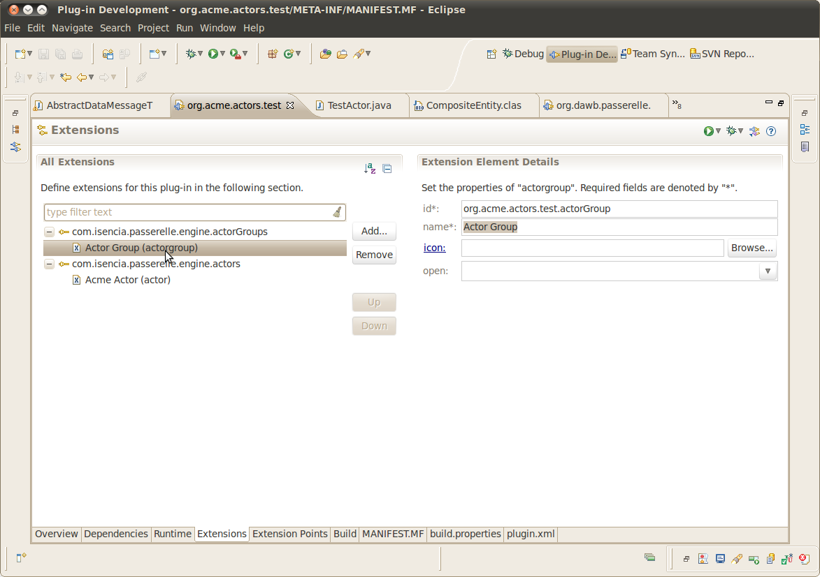
Actor Group

Actor
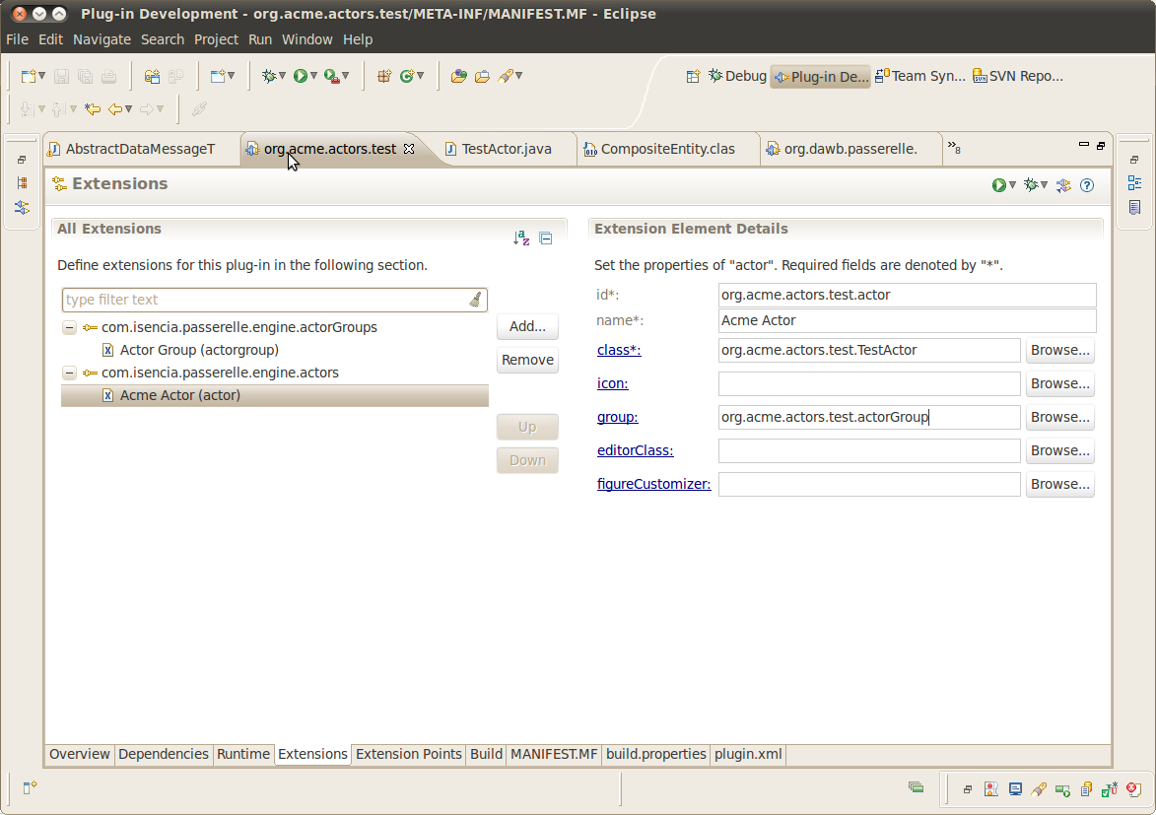

NOTE Choose icons for your groups and actors to make them look better in the user interface.

Use The New Actor
Now simply start the debug session which you had working in step one. You will see a new category and actor have appeared! Create a workflow similar to the one below to test this actor:
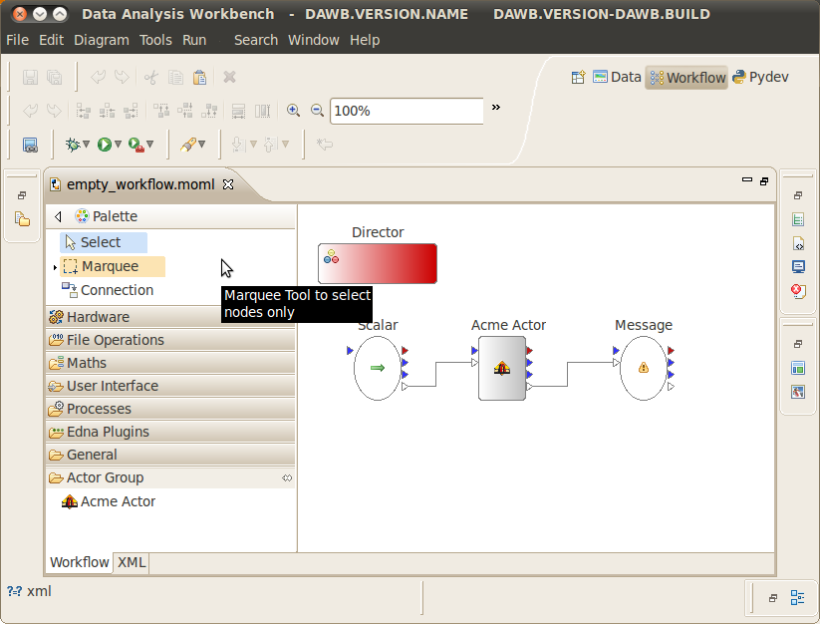
When run the message “Hello World” is displayed from the message actor.

Exporting The Plugin
You can export this plugin to run with the compiled DAWB (on the 'Overview' tab in the eclipse editor 'org.acme.actors.test') then copy it to plugins or contribute it back to the source code repository for everyone to use whenever DAWB is used.
If you want keep what it does private, it is possible to use obfuscation. Obfuscation is a method whereby the java class files are changed such that they run but if decompiled, do not make sense. There is a free obfuscator here: http://www.yworks.com/en/products_yguard_about.html
which is excellent. Do not forget to keep the class names of your actors the same if obfuscating, so that eclipse can load them.

...And Now
It is easy to add your own actors to run in the system, once you can get over the initial hurdles of understanding eclipse. Don't forget to use debugging of your actor to really understand it. Take a look at more complex actors in the plugin org.dawb.passerelle.actors which will help with custom parameters and interacting with the GUI if required.

